**OFFICE NETWORK**

**Tasks to do**

* **OSPF routing**
* **Host isolation method (VLAN)**

**Scheme :**

Suppose, there is a only a main switch at the centre of an office, and both HR and FINANCE are connected by this main switch. Now, the condition is HR will communicate with HR and FINANCE will communicate with FINANCE.

But there will be no communication between HR and FINANCE.

So, the whole network diagram is according to the description.

**Network Design:**

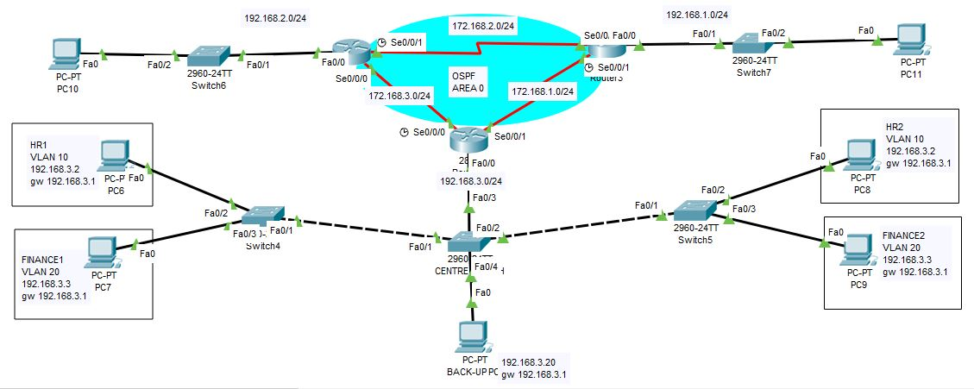

**Configuration:**

**<R1>**

(config)#router ospf 10

Router(config-router)#router-id 3.3.3.3

Router(config-router)#network 172.168.3.0 255.255.255.0 area 0

Router(config-router)#network 172.168..0 255.255.255.0 area 0

Router(config-router)#network 192.168.3.0 255.255.255.0 area 0

**<R2>**

Router(config)#router ospf 10

Router(config-router)#router-id 1.1.1.1

Router(config-router)#network 192.168.2.0 255.255.255.0 area 0

Router(config-router)#network 172.168.2.0 255.255.255.0 area 0

Router(config-router)#network 172.168.3.0 255.255.255.0 area 0

**<R3>**

Router(config)#router ospf 10

Router(config-router)#router-id 2.2.2.2

Router(config-router)#network 172.168.2.0 255.255.255.0 area 0

Router(config-router)#network 172.168.1.0 255.255.255.0 area 0

Router(config-router)#network 192.168.1.0 255.255.255.0 area 0

**<S1>**

S1#show vlan brief

10 hr1 active Fa0/2

20 fin1 active Fa0/3

99 native active

S1#show int trunk

Port Mode Encapsulation Status Native vlan

Fa0/1 on 802.1q trunking 99

Port Vlans allowed on trunk

Fa0/1 1-1005

Port Vlans allowed and active in management domain

Fa0/1 1,10,20,99

Port Vlans in spanning tree forwarding state and not pruned

Fa0/1 1,10,20,99

**<S2>**

**S2#show vlan brief**

10 hr2 active Fa0/2

20 fin2 active Fa0/3

99 native active

S2#show int trunk

Port Mode Encapsulation Status Native vlan

Fa0/1 on 802.1q trunking 99

Port Vlans allowed on trunk

Fa0/1 1-1005

Port Vlans allowed and active in management domain

Fa0/1 1,10,20,99

Port Vlans in spanning tree forwarding state and not pruned

Fa0/1 1,10,20,99

**<mainswitch>**

Mainswitch#show vlan b

10 hr active

20 fin active

99 native active

Mainswitch#sh int t

Port Mode Encapsulation Status Native vlan

Fa0/1 auto n-802.1q trunking 99

Fa0/2 on 802.1q trunking 99

Port Vlans allowed on trunk

Fa0/1 1-1005

Fa0/2 1-1005

Port Vlans allowed and active in management domain

Fa0/1 1,10,20,99

Fa0/2 1,10,20,99

Port Vlans in spanning tree forwarding state and not pruned

Fa0/1 1,10,20,99

Fa0/2 1,10,20,99

**Check for communication:**

Now as per condition, HR will ping with HR, FINANCE will ping with FINANCE.

But HR to FINANCE no ping.

